(Approx. 856 words)

Info, Info Everywhere, and Not a Thought to Think
By Vinny La Bash, Columnist, Sarasota PCUG, Florida
www.spcug.org
labash(at)spcug.org

Obtained from APCUG with the author's permission for publication by APCUG member groups.

Many people think that the internet is the greatest thing since sliced whatchamacallit or the worst abomination that’s ever been inflicted upon the human race. As usual the truth lies somewhere in-between. There is no doubt that the internet is a great source of seemingly limitless information, and the information found there tends to fall into three general categories:

- Information which is totally useless. Did you know that the average cloud weighs 300,000 pounds? Neither did I, but that’s the sort of thing you are most likely to get on the internet unless you are careful.

- Information which is useful, but not at the moment. I invariably discover a great tax deduction I didn’t know about on April 16th. It’s too late for this year, and I will probably either forget about it next year or misfile the thing where I can’t find it.

- Information which is useful now. This is extraordinarily rare, comparable to finding eyebrows on eggs, but we all get lucky occasionally.

The data you find in the first category is not only safe to ignore, it’s essential to your sanity to ignore it. The third category usually takes care of itself. Simply use it for whatever purpose you have in mind and you’re done. The second category is the one that requires a good degree of sound management to avoid wasting time, and that is the problem.

World wide productivity could double overnight if the internet would only send us the information we need at the right time. We spend too much time refining our Google searches, investigating blogs, experimenting with RSS feeds or mucking around our own data bases. One piece of missing information has the potential to make the best presentation look like the product of a misinformed dolt.

Is having the information you need when you need it nothing more than a World Wide Web fantasy? Perhaps not. Did you know that you can set a reminder email for future delivery in Outlook? Here’s how to do it:

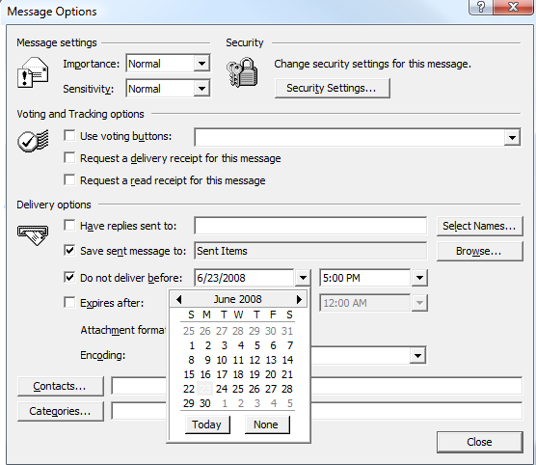
- Open Outlook (obviously).
- Select the email to forward.
- Click on the Forward button.
- Click on the Options… button.
- Put a check in the Do not deliver before box.
- Select the date of delivery.
- Click Close.

Don’t set a delivery date to a point where you are unlikely to have your present computer unless you are in a corporate network where the systems administrator can make the proper adjustments. Even then, be realistic.

Send yourself notes about meetings shortly before you need them. Include information not only about the subject of the meeting, but about the people attending with you. Your colleagues will think you’re a certified genius.

All kinds of things can be done with Outlook and its future delivery capabilities. The usual subjects such as birthdays, anniversaries, and recurring meetings suggest themselves. Investors can send themselves reminders that an option they own is about to expire or to watch for that important dividend payment. Almost any kind of regular to-do item lends itself to this task. Get that tax form in the mail by April 15th. Do you really need a reminder for that?

What do you do if you don’t have Outlook? Neither Yahoo, Hotmail nor Outlook Express offers this feature, but there is a web site that can help. Go to www.futureme.org and create your email for future delivery. This site is well suited for information you won’t need for months if not years. Of course, delivery depends on the web site still being in existence when you need it, and it doesn’t handle attachments. If you can live with those limitations, go for it.

People talk a lot about traffic congestion, but unlike the weather, you can do something about it. If you commute regularly to work take a peek at www.traffic.com. The site will send you real-time traffic maps, road condition alerts and jam alerts. This site is great for road warriors or anyone who drives over regular routes.

Do you suffer from springtime allergies? Then take a trip to www.weather.com to have pollen, weather, and other alerts delivered directly to your desktop. Not everything has to be delivered by email.

Cutting down on information overload is the best reason for using these tools. Avoiding data until you need it will free you from the drudgery of sifting through piles of irrelevant information to find the one item you need, and best of all, you won’t worry about being unprepared when an unexpected deadline suddenly looms up before you.

Use information efficiently and you will become respected, admired, and the opposite sex will seek you out. When people inevitably accuse you of having a perfect memory, tell them you have a photogenic mind.

This article has been provided to APCUG by the author solely for publication by APCUG member groups. All other uses require the permission of the author (see e-mail address above).

